Using the compilation of NMT1, THI5, ThiY and SSUA in the NMT1_THI5_THIY.fasta file I used MUSCLE in the MEGA X platform to perform a MSA with the following parameters:

MUSCLE

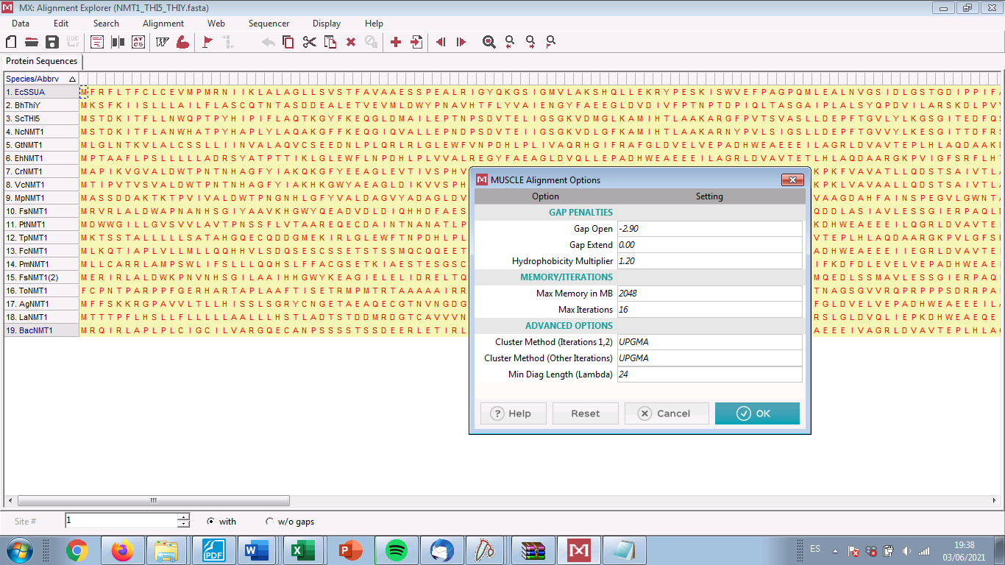

I use the resulting MSA as the input to run a phylogeny reconstruction using the Maximum Likelihood algorithm with the following parameters:

Maximum Likelihood Tree

